CSCI/CMPE 4301 DIP Guide
One sheet of notes.
Jupytor notebook
Exam-02 Name:
The second exam will have these 5 question types exactly.

Show all work for full credit.
- (30) Given a 5x5 image, f(x,y) with a 3x3 mask h(x,y), compute the convolution image, g(x,y) = f(x,y) * h(x,y).You can ignore boundary pixels (put them as 0s). See the lecture notes slides for the complete example I added with visualization. (+/-)

- (20) Identify 2 low pass filters and two high pass filters in the spatial domain each with 3x3 elements. (+/-)
- (10) Given an image of a filter in the frequency domain, you should be able to identify it as low or high pass. (+/-)

- (10) How would you write the following relationship in the frequency domain (V)
g(x,y) = f(x,y) * h(x,y)

G(u,v) = F(u,v) (convolution) H(u,v)

- (30) Create a notebook in Jupytor and compute the DFT of a given 1-d signal such as f(n)={1,1,1,0,0,0,0,} using open CV and manually from the formula. (V)
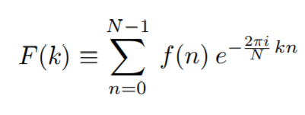

- I have created a sample notebook with all the calculations. I will post a video of it today or tomorrow at most (sine I don’t want to share the notebook with you to make sure you create it yourself) (V)

